Implementing Remote Backend Operations in Terraform Cloud

Create a Terraform Cloud Workspace using Terraform:

1. 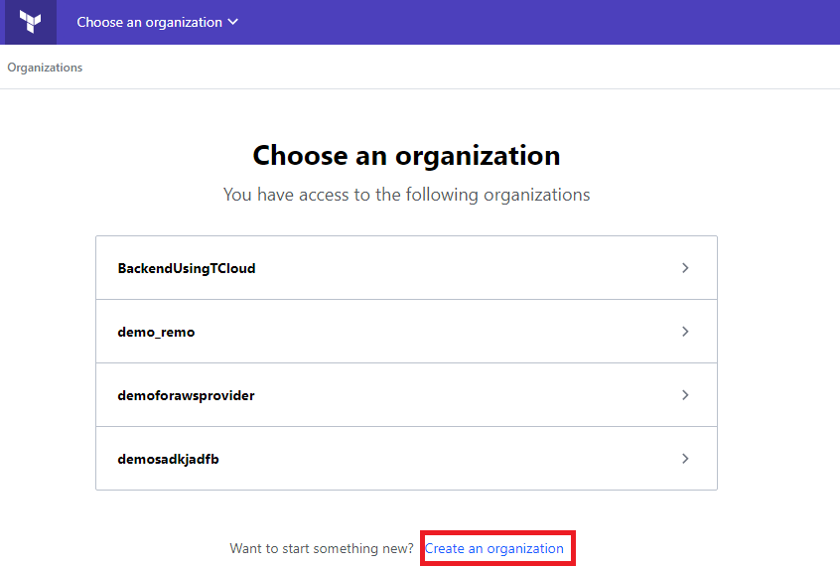Login Your Terraform Cloud Account. Create New Organization.

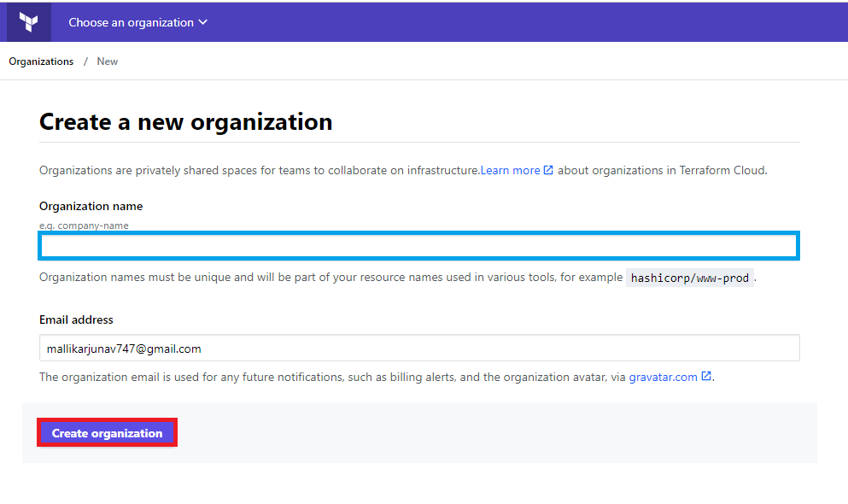2. Enter Your Organization Name Below and click create.

3. Next click on Account symbol.



4. Goto User Settings.

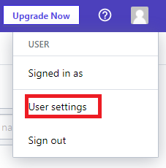

5. Click on Tokens.

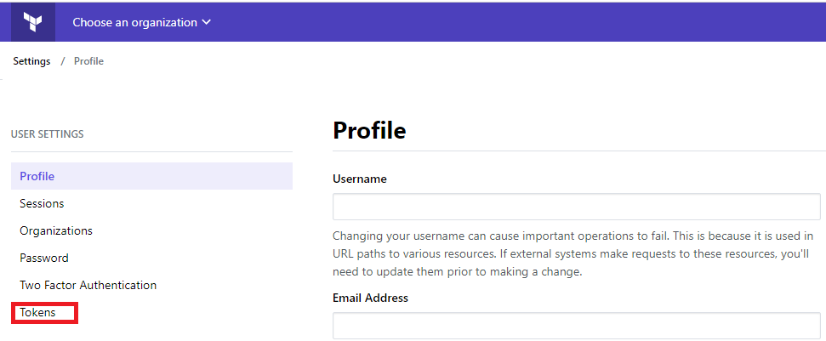

6.Click on Create Token .

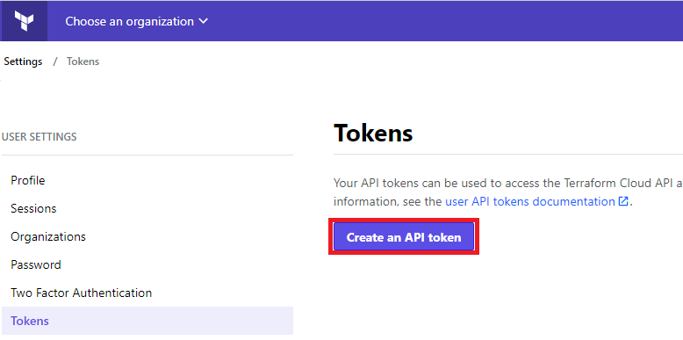7. Next enter default description for token and click create API.

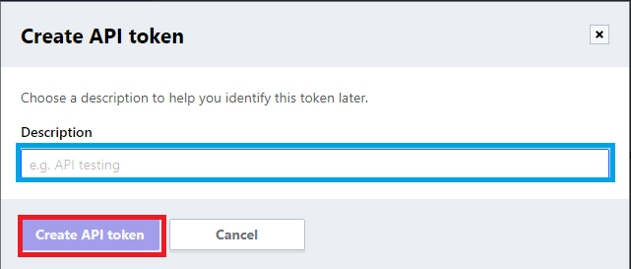

8. Copy and paste the token ID for future reference and close window.

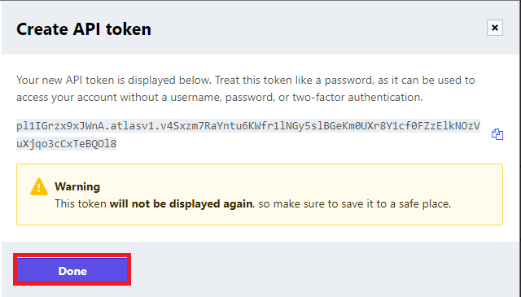

9. Next goto your terraform installation terminal. Click on terraform login.

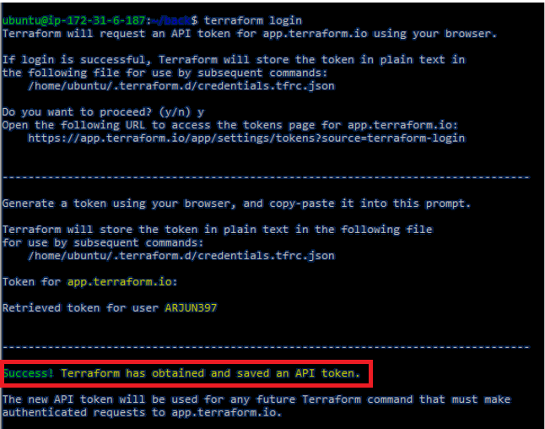

10. You can create one directory go to the directory and create main.tf file. The file contains following code.

terraform {

backend "remote" {

hostname = "app.terraform.io"

organization = "my-pablosspot"

workspaces {

name = "ps-access-key-generator"

}

}

}

11. Next you can do terraform init and terraform apply.

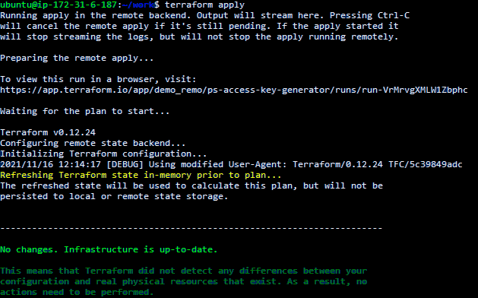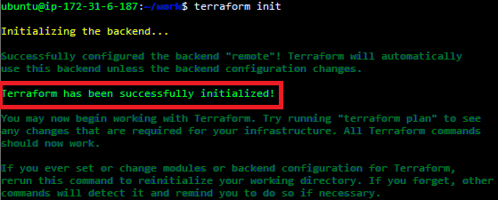

12. Once Apply Complete Check in your Terraform cloud.

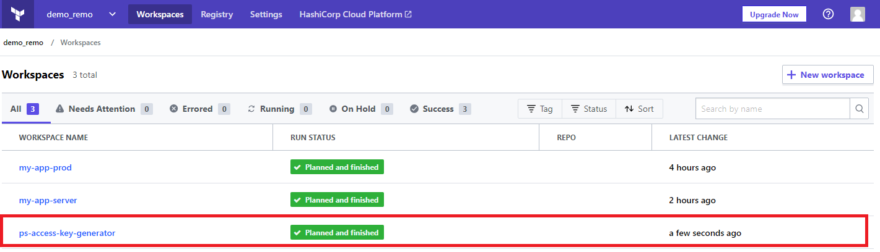

13. Implementing Backend Operations in terraform. First we can create one s3 bucket. Next we can create backend.tf file .The file contains following code.

terraform {

backend "s3" {

bucket = "backenddemo"

key = "terraform.tfstate"

region = "ap-south-1"

encrypt= "false"

}

}

14. next install aws cli using sudo apt-get install awscli command. After the add aws configurations using aws configure command.

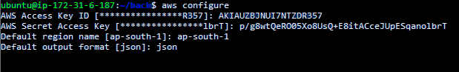

15. After that you have to do terraform init.



16. Next do terraform apply.



17. After go to AWS console s3 bucket check it.

